(Insert your Club’s logo here)

A Proposal Requesting Funds from (insert company name)
To support the (Boys & Girls Club of)_________’s
Brain Gain
An educational summer program
for youth ages 6 to 18

(Insert Date)

Contents

(insert page numbers below
when proposal is complete)

Executive Summary | #
Organizational Background | #
Statement of Need | #
Responding to the Need | #
Budget and Plan for Sustainability | #
Marketing/Publicity Plan | #
Closing | #
Appendix | #

Executive Summary

For (insert number) years, Boys & Girls Club of _______________ has been at the forefront of youth development. We have worked with over __________ disadvantaged young people that other youth-serving organizations have struggled to reach. Going forward, we are dedicated to ensuring that all of our community’s young people have greater access to programs that will help them shape great futures.

One type of program that is desperately needed in our community is summer programming with a strong academic component. Numerous studies show that most youth lose about two months of grade-level equivalency in mathematical computation skills over the summer months. Low income youth also lose more than two months in reading achievement. As a matter of fact, two-thirds of the ninth grade reading achievement gap between disadvantaged students and their more advantaged peers can be explained by unequal access to summer learning opportunities during the elementary school years.

To address this need, Boys and Girls Clubs of America has developed and tested a new program called Summer Brain Gain. Summer Brain Gain adds engaging, educational activities to the typical summer camp experience and is for youth ages 6 to 18. While the average low-income U.S. student lost at least two months of learning last summer, the average Summer Brain Gain participant did not experience learning loss. Moreover, some Club members actually experienced gains in learning – especially in vital 21st century skills, like collaboration and critical thinking. This is very encouraging, given that most youth experience significant summer learning loss.

To maximize our impact over the summer, Boys & Girls Club of ____________ is requesting funding from (insert company’s name here) to implement Summer Brain Gain. To implement Summer Brain Gain, we request the amount of $___. A detailed breakdown of how these dollars will be allocated can be found in this proposal’s Budget and Plan for Sustainability.

(insert company’s name here) seeks to help our community’s youth become responsible, caring, productive citizens. Boys & Girls Club of _______________ has the staff and tools necessary to see this vision come to life. We thank you for considering this request. Together, we can ensure that our community’s youth go on to have great futures.

Organizational Background

The Boys & Girls Club of ______________ is part of a nationwide Movement of community-based, autonomous organizations, part of the Boys & Girls Clubs of America (BGCA) working to help youth of all backgrounds develop the qualities needed to become responsible citizens and leaders. It offers daily access to a broad range of programs in five core program areas (Character and Leadership Development; Education and Career Development; Health and Life Skills; The Arts; and Sports, Fitness and Recreation) and several specialized initiatives. All programs are designed to drive positive outcomes for youth and reinforce necessary life skills.

Today, more than (insert number) young people at risk and in need are taking advantage of the programs, activities and services provided by the Boys & Girls Club of ____________. Our vision is to provide a world-class Club Experience that assures success is within reach of every young person who comes through our doors, with all members on track to graduate from high school with a plan for the future, demonstrating good character and citizenship, and living a healthy lifestyle.

(Insert additional information and accolades here about your local Club)

To make sure that all of our members have great futures, the Boys & Girls Club Movement has adopted the Formula for Impact, a research-based theory of change that describes how individual Clubs and the Movement as a whole can increase our impact – exponentially – on the young people of America.

Our Formula begins with the young people in Clubs – especially those who need us most. It calls for us to consistently provide the most powerful Club Experience possible – by implementing the Five Key Elements for Positive Youth Development, offering high-yield activities and providing targeted programs – all of which help youth achieve priority outcomes. Then, because we also know that attending the Club more frequently and over a greater length of time makes young people more likely to achieve positive outcomes, Clubs must pursue strategies to increase attendance, program participation and member retention.

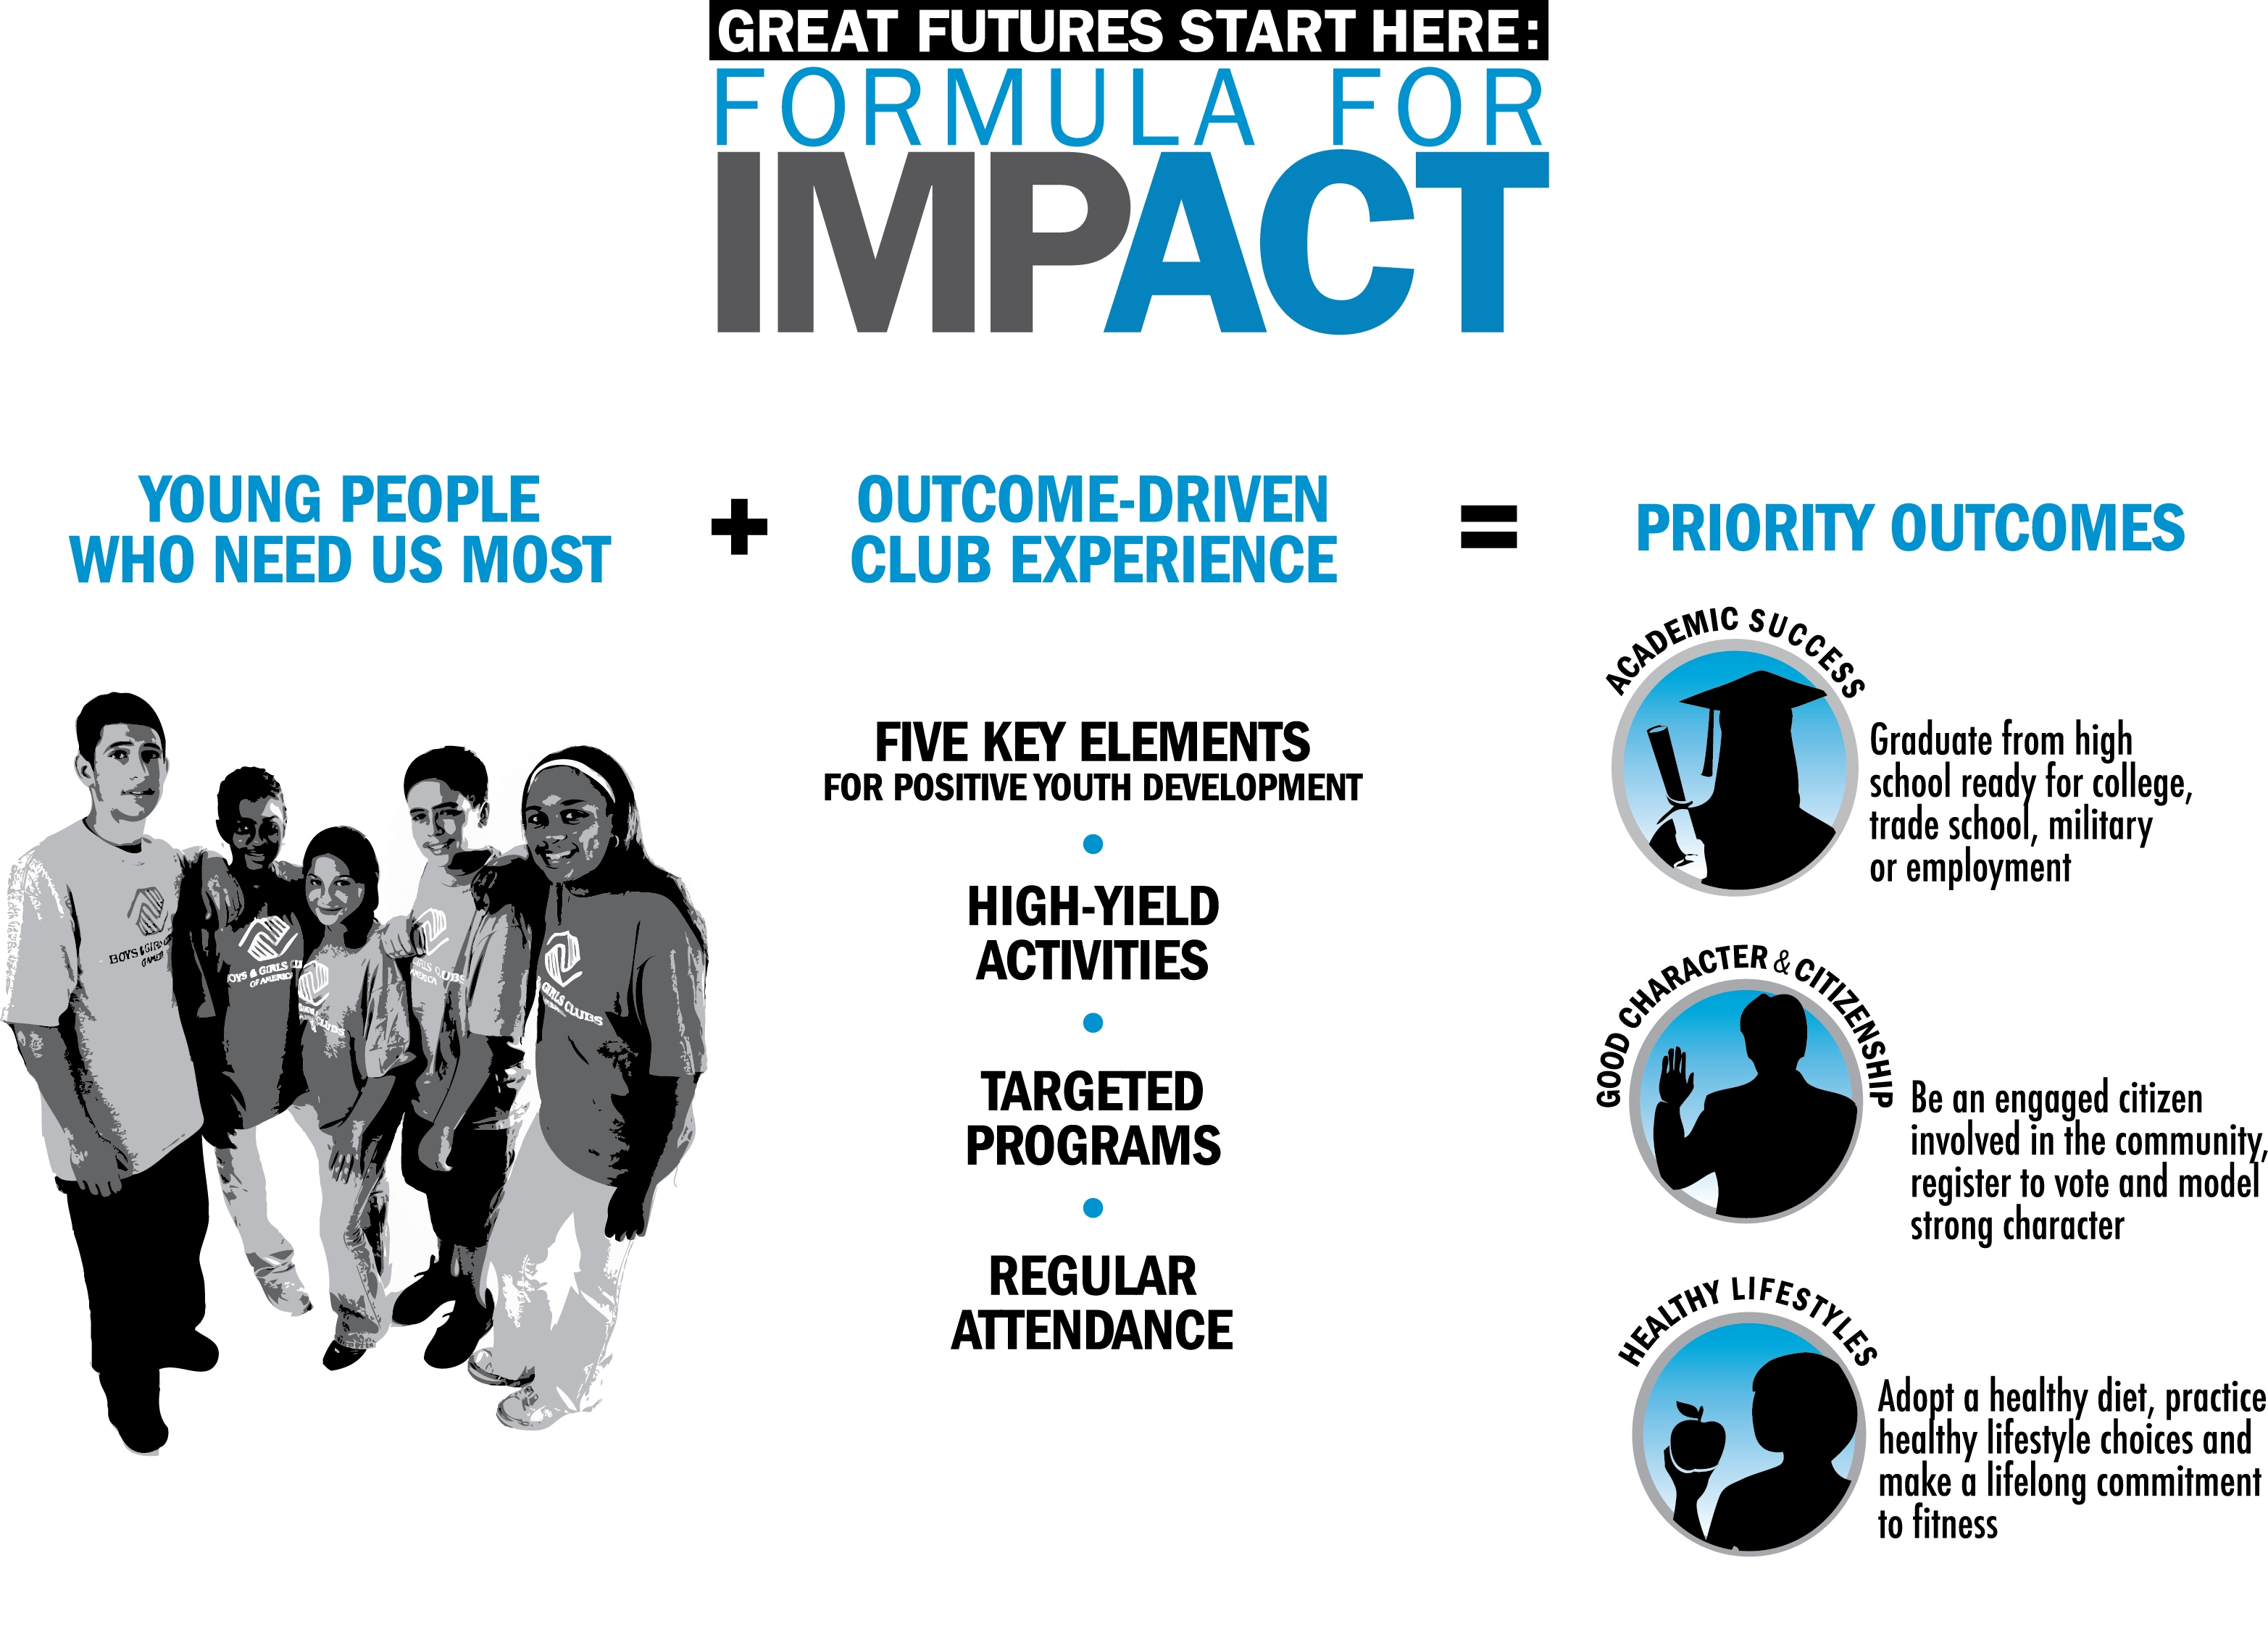
Statement of Need

Now more than ever, community partners play a critical role in shaping the lives of America’s young people. Boys & Girls Clubs are uniquely positioned to make a significant difference. We engage the youth who need us most, and provide programs that will help youth develop positive outcomes and achieve great futures.

One type of program that is desperately needed across the nation is summer programming with a strong academic component. Numerous studies show that most youth lose about two months of grade-level equivalency in mathematical computation skills over the summer months. Low income youth also lose more than two months in reading achievement. As a matter of fact, two-thirds of the ninth grade reading achievement gap between disadvantaged students and their more advantaged peers can be explained by unequal access to summer learning opportunities during the elementary school years.

Our community faces these issues outlined in the national research. In (insert name of your community), (insert local dropout rate and other relevant statistics and information demonstrating educational needs of local youth, including demographic characteristics of the youth population served by the Club, statistics from schools on standardized test scores, or other related data.)

Responding to the Need

Boys and Girls Clubs of America has developed and tested a new program called Summer Brain Gain. Summer Brain Gain adds engaging, educational activities to the typical summer camp experience for youth ages 6 to 18. For example, it adds weekly thematic modules that build to a final, culminating project or event. Many of the weekly modules are based on Project Based Learning principles and involve working in groups. Finally, Summer Brain Gain modules are available at elementary, middle and high school levels.

Boys & Girls Clubs of America (BGCA) selected Metis Associates, a national research and evaluation firm with special expertise in education and youth development, to conduct a multi-year evaluation of the Summer Brain Gain initiative. In 2013 and 2014, Metis completed a formative evaluation of Summer Brain Gain and answered the following questions.
- What is the nature and quality of program implementation?
- What are the main implementation challenges?
- What are the stakeholders’ perceptions of the program?
- Does Brain Gain help prevent summer learning loss?
- To what extent do participants show improved outcomes in other areas?

To answer these questions, the Metis team selected a stratified sample of Clubs, completed case studies, conducted reading and math pretests and posttests, conducted pre and post program participant surveys, analyzed data from daily and weekly instructor implementation logs, and conducted a staff survey.

Metis found that, while the average low-income U.S. student lost at least two months of learning last summer, on average, participants in most grades showed no significant change in reading or math scores, some Club members actually experienced gains in reading, math, and/or vital 21st century skills, like collaboration and critical thinking. The past two years of evaluation have yielded very promising results and suggest that a rigorous impact evaluation of Summer Brain Gain may enable BGCA to certify it as an evidence-based program.

In 2015, Metis will conduct a more rigorous evaluation designed as a randomized control trial (RCT). A sample of randomly selected Clubs will serve as treatment (“implementation”) sites, and a sample of randomly selected Clubs will serve as control (“comparison”) sites. This level of evaluation will provide huge benefits for many years to come by enabling Clubs to more convincingly and effectively demonstrate their impact.

Program Implementation and Measurement

(Explain how this program will be implemented in your Club – how often, who will coordinate and staff it, what resources will be needed to enhance the program; whether additional staff or content experts will be needed.)

Measuring the degree to which youth participants achieve Summer Brain Gain’s desired outcomes is a critical aspect of how the program is implemented. Data is collected and tracked on indicators such as:

- how frequently youth attend the program
- include any other data you plan to collect during the summer program

(Explain how the program will be evaluated in your Club, what data collection tools will be used, and what will be reported to the funder.)

(Give anecdotal evidence for why implementing this program with the prospective funding source’s support is a good fit.)
Budget and Plan for Sustainability

The Boys & Girls Club of ___________________ requests $______ from (insert company’s name here) to support the Summer Brain Gain program. Funding will provide for the (staffing, equipment, etc.) necessary to operate the program. The program will operate at (number of Club sites) throughout (town/ city/area). The following budget outlines the specific cost breakdowns.
Salaries | $
Program coordinator
Program staff (full-time or part-time)
Benefits | $
@ _____________ percent
Professional Fees | $
Master teachers, tutors, literacy coaches, evaluator, etc.
Supplies | $
Books from First Book Marketplace, educational software, board games, basic school supplies, reference materials and magazines appropriate for different age ranges and interests, motivational posters, healthful snacks, incentive prizes, recognition awards, etc.
Equipment | $
White boards, bookcases, portable storage bins, hard and soft furnishings, computers, Internet access, TV, DVD player, camcorder, portable stereo, etc.
Travel and Training | $
In-service staff sessions, outside training with other agencies
Telephone | $
Printing/Photocopies | $
Postage/Shipping | $
Special Events and Field Trips | $
Miscellaneous/Other | $
Indirect Costs (percent) | $
GRAND TOTAL | $
(As needed, elaborate on the paragraph below. Explain who your Club is working with to secure additional funding and resources to sustain the program, if applicable. Are you also requesting the funder provide volunteers for the program through employee engagement? Are there other local funders you wish to approach for funding and/or resources?)

In addition to the financial request above, Boys & Girls Club of __________________ is working with other local organizations to provide for the long-term sustainability of the Summer Brain Gain program.

Marketing and Publicity Plan

Boys & Girls Club of ___________________ will be happy to acknowledge the contributions of (insert company’s name here) for their support of Sumer Brain Gain in appropriate communications. This includes, but is not limited to, (insert the places the funder will receive acknowledgment of program support – newsletters, e-newsletters, Club website, program flyers, etc.).

Closing

High school graduation and successful completion of post-secondary education goals only grow more and more important for the young people in our community. Stemming summer learning loss is critical component of staying on track toward these goals. Boys & Girls Club of ____________________ is determined to help young people fight summer learning loss while having fun and productive summers by providing the Summer Brain Gain program at the Club this year.

Thank you for considering this request and for your support of our community’s young people. With the support of (insert company’s name here), we can ensure that our community’s youth go on to become productive, caring, responsible citizens.

Appendix

(Annual Report)

(Board of Directors)

(Other Important Club Information)
Endnotes

? Alexander, K.L., Entwisle, D.R. & Olson, L.S. (2007). Lasting consequences of the summer learning gap. American Sociological Review 72, 167-180.
? Alexander, K.L., Entwisle, D.R. & Olson, L.S. (2007). Lasting consequences of the summer learning gap. American Sociological Review 72, 167-180.
Five Key Elements for Positive Youth Development: BGCA worked with the nationally recognized Search Institute to review relevant research and study highly effective Clubs. Through Club visits and interviews with managers, program staff, teens and community leaders, the five key elements that determine the level of impact a Club makes on the development of young people were identified. High-yield activities: The research of Dr. Reginald Clark has demonstrated that high-achieving students spend more time engaged in activities that reinforce the skills and knowledge they learn in school. “Enhancing the Educational Achievement of At-Risk Youth,” an evaluation of BGCA’s national education strategy, Project Learn, confirms the effectiveness of using such high-yield activities in Boys & Girls Clubs. Targeted programs: BGCA offers many national programs that are designed to help young people achieve our priority outcomes of academic success, good character and citizenship, and healthy lifestyles. Many of BGCA’s targeted programs have been evaluated for their effectiveness. Some of BGCA’s targeted programs have also been deemed “evidence based” by the federal government.
“Making Every Day Count: Boys & Girls Clubs’ Role in Promoting Positive Outcomes for Teens.” Public/Private Ventures, 2009. This national, longitudinal study links participation in the Club to young people’s positive and healthy development in BGCA’s three priority outcome areas.

